### **1. Understanding Asymptotic Notation**

#### **Big O Notation**

Big O notation is a mathematical notation used in computer science to describe the performance or complexity of an algorithm. It specifically describes the worst-case scenario, providing an upper bound on the execution time or space requirements of an algorithm in relation to the size of the input data.

In essence, Big O notation helps us answer the question: "As the input to our algorithm grows, how much slower will it run?" This allows us to compare the efficiency of different algorithms and make informed decisions about which one to use.

Here are some common Big O complexities:

* **O(1) (Constant Time):** The algorithm takes the same amount of time to execute, regardless of the input size.
* **O(logn) (Logarithmic Time):** The execution time grows logarithmically with the input size. This is very efficient for large datasets.
* **O(n) (Linear Time):** The execution time is directly proportional to the input size.
* **O(n2) (Quadratic Time):** The execution time is proportional to the square of the input size. This becomes inefficient very quickly as the input size grows.

#### **Best, Average, and Worst-Case Scenarios for Search Operations**

When analyzing a search algorithm, we consider three scenarios:

* **Best-Case Scenario:** This is the most favorable situation for the algorithm. For a search operation, the best case is typically finding the desired element on the first attempt.
* **Average-Case Scenario:** This represents the expected performance of the algorithm over a random distribution of inputs. It's the most realistic measure of an algorithm's performance.
* **Worst-Case Scenario:** This is the least favorable situation, where the algorithm takes the maximum amount of time to complete. For a search, this often means the element is at the very end of the dataset or not present at all. Big O notation primarily focuses on this scenario.

**2. Setup:**

**Product.java -**

// File: Product.java

public class Product {

private int productId;

private String productName;

private String category;

public Product(int productId, String productName, String category) {

this.productId = productId;

this.productName = productName;

this.category = category;

}

public int getProductId() {

return productId;

}

public String getProductName() {

return productName;

}

public String getCategory() {

return category;

}

@Override

public String toString() {

return "Product(ID: " + productId + ", Name: '" + productName + "', Category: '" + category + "')";

}

}

**3. Implementation: Search Algorithms**

**ECommerceSearch.java-**

import java.util.Arrays;

import java.util.Comparator;

public class ECommerceSearch {

public static Product linearSearch(Product[] products, int targetId) {

for (Product product : products) {

if (product.getProductId() == targetId) {

return product;

}

}

return null; // Not found

}

public static Product binarySearch(Product[] products, int targetId) {

int left = 0;

int right = products.length - 1;

while (left <= right) {

int mid = left + (right - left) / 2;

if (products[mid].getProductId() == targetId) {

return products[mid];

}

if (products[mid].getProductId() < targetId) {

left = mid + 1; // Search in the right half

} else {

right = mid - 1; // Search in the left half

}

}

return null; // Not found

}

public static void main(String[] args) {

// Setup: Create an array of products in an unsorted order

Product[] products = {

new Product(105, "Jeans", "Apparel"),

new Product(101, "Laptop", "Electronics"),

new Product(104, "Smartphone", "Electronics"),

new Product(102, "T-shirt", "Apparel"),

new Product(103, "Coffee Maker", "Home Goods")

};

// --- Linear Search Demonstration (on the original unsorted array) ---

System.out.println("--- Linear Search ---");

System.out.println("Searching for Product ID 104...");

Product foundProductLinear = linearSearch(products, 104);

System.out.println("Result: " + foundProductLinear);

System.out.println("\nSearching for Product ID 106 (which doesn't exist)...");

Product notFoundProductLinear = linearSearch(products, 106);

System.out.println("Result: " + notFoundProductLinear);

System.out.println("---------------------\n");

// --- Binary Search Demonstration ---

// Step 1: Sort the array by productId. This is a prerequisite for binary search.

Arrays.sort(products, Comparator.comparingInt(Product::getProductId));

System.out.println("--- Binary Search (on a sorted array) ---");

System.out.println("Searching for Product ID 104...");

Product foundProductBinary = binarySearch(products, 104);

System.out.println("Result: " + foundProductBinary);

System.out.println("\nSearching for Product ID 106 (which doesn't exist)...");

Product notFoundProductBinary = binarySearch(products, 106);

System.out.println("Result: " + notFoundProductBinary);

System.out.println("---------------------\n");

}

}

**ECommerceSearch.class -**

// Source code is decompiled from a .class file using FernFlower decompiler.

import java.util.Arrays;

import java.util.Comparator;

public class ECommerceSearch {

public ECommerceSearch() {

}

public static Product linearSearch(Product[] var0, int var1) {

Product[] var2 = var0;

int var3 = var0.length;

for(int var4 = 0; var4 < var3; ++var4) {

Product var5 = var2[var4];

if (var5.getProductId() == var1) {

return var5;

}

}

return null;

}

public static Product binarySearch(Product[] var0, int var1) {

int var2 = 0;

int var3 = var0.length - 1;

while(var2 <= var3) {

int var4 = var2 + (var3 - var2) / 2;

if (var0[var4].getProductId() == var1) {

return var0[var4];

}

if (var0[var4].getProductId() < var1) {

var2 = var4 + 1;

} else {

var3 = var4 - 1;

}

}

return null;

}

public static void main(String[] var0) {

Product[] var1 = new Product[]{new Product(105, "Jeans", "Apparel"), new Product(101, "Laptop", "Electronics"), new Product(104, "Smartphone", "Electronics"), new Product(102, "T-shirt", "Apparel"), new Product(103, "Coffee Maker", "Home Goods")};

System.out.println("--- Linear Search ---");

System.out.println("Searching for Product ID 104...");

Product var2 = linearSearch(var1, 104);

System.out.println("Result: " + var2);

System.out.println("\nSearching for Product ID 106 (which doesn't exist)...");

Product var3 = linearSearch(var1, 106);

System.out.println("Result: " + var3);

System.out.println("---------------------\n");

Arrays.sort(var1, Comparator.comparingInt(Product::getProductId));

System.out.println("--- Binary Search (on a sorted array) ---");

System.out.println("Searching for Product ID 104...");

Product var4 = binarySearch(var1, 104);

System.out.println("Result: " + var4);

System.out.println("\nSearching for Product ID 106 (which doesn't exist)...");

Product var5 = binarySearch(var1, 106);

System.out.println("Result: " + var5);

System.out.println("---------------------\n");

}

}

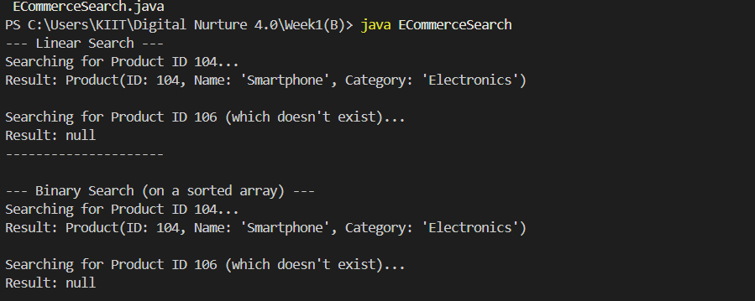

### **4. Analysis: Comparing Search Algorithms**

#### **Time Complexity**

|  |  |  |  |
| --- | --- | --- | --- |
| **Algorithm** | **Best-Case** | **Average-Case** | **Worst-Case** |
| **Linear Search** | O(1) | O(n) | O(n) |
| **Binary Search** | O(1) | O(logn) | O(logn) |

* **Linear Search (O(n)):** In the worst-case scenario (the item is the last element or not in the list), we have to look at every single one of the 'n' items. This means the time it takes to search grows linearly with the number of products.
* **Binary Search (O(logn)):** Because we halve the search space with each comparison, the number of comparisons grows much more slowly. For example, for a list of 1,000,000 products, binary search would take at most around 20 comparisons, while linear search would take up to 1,000,000 comparisons in the worst case.

#### **Which Algorithm is More Suitable for Your Platform?**

For an e-commerce platform's search functionality, **binary search is significantly more suitable** from a pure performance perspective, but with a crucial caveat.

**Why Binary Search is Better:**

* **Performance and Scalability:** As the number of products on the platform grows, the performance of a linear search will degrade significantly, leading to slow response times for users. A binary search will remain extremely fast even with millions of products.
* **User Experience:** Fast search results are critical for a good user experience and for converting searches into sales. Slow searches can lead to user frustration and abandonment of the site.

**The Important Caveat: The Need for a Sorted List**

Binary search's major prerequisite is that the data must be sorted. For an e-commerce platform, this has implications:

* **Data Modification:** Products are constantly being added, removed, or updated. Every time a new product is added, the list would need to be re-sorted, or the product would need to be inserted in the correct sorted position. Maintaining a sorted array can be computationally expensive if there are frequent writes (additions, updates, deletions).

In the context of this exercise, **binary search is the clear winner for optimizing the search operation**. It demonstrates a fundamental principle of algorithmic optimization. However, in a real-world application, the principle of using efficient, indexed data structures (as provided by databases and search engines) is the practical extension of the concepts demonstrated by binary search.